To plot Even and Odd parts of a discrete time signal

% DISCRETE of x(n)=0.8^n

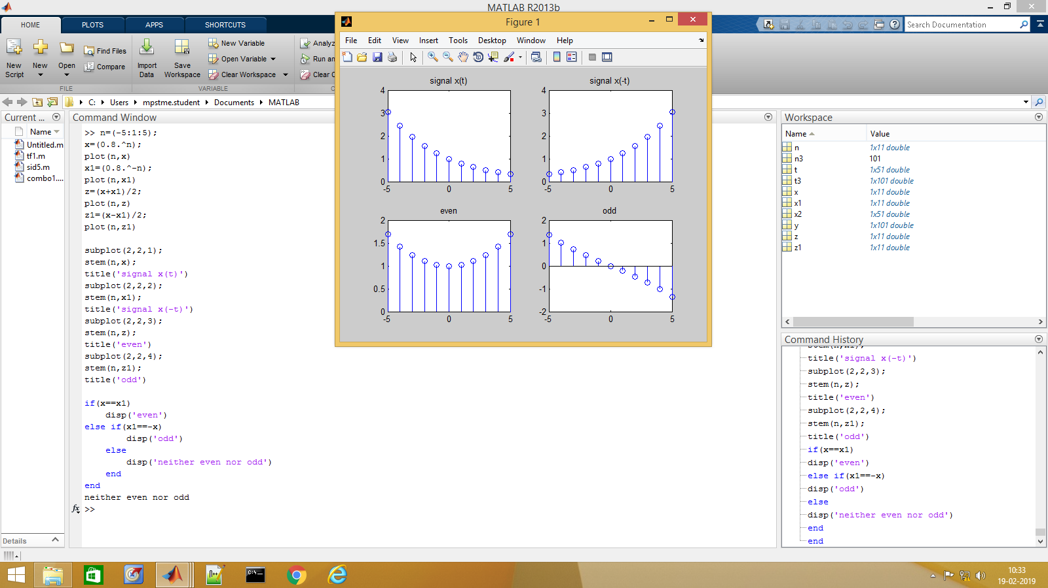

>> n=(-5:1:5);

x=(0.8.^n);

plot(n,x)

x1=(0.8.^-n);

plot(n,x1)

z=(x+x1)/2;

plot(n,z)

z1=(x-x1)/2;

plot(n,z1)

subplot(2,2,1);

stem(n,x);

title('signal x(t)')

subplot(2,2,2);

stem(n,x1);

title('signal x(-t)')

subplot(2,2,3);

stem(n,z);

title('even')

subplot(2,2,4);

stem(n,z1);

title('odd')

if(x==x1)

disp('even')

else if(x1==-x)

disp('odd')

else

disp('neither even nor odd')

end

end

neither even nor odd